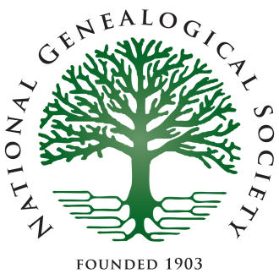
NATIONAL GENEALOGICAL SOCIETY
3108 Columbia Pike, Suite 300
Arlington, VA 22204-4370
Phone 703-525-0050 or 800-473-0060
Fax 703-525-0052
http://www.ngsgenealogy.org/

Press Release

Contact: Erin Shifflett
Phone: 703-525-0050 ext. 112
eshifflett@ngsgenealogy.org
For Release: 24 April 2017

Mobile Conference App Now Available
for the
NGS 2017 Family History Conference

ARLINGTON, VA, 24 APRIL 2017—The Mobile Conference App for the National Genealogical Society (NGS) 2017 Family History Conference is now available. This conference will be held in Raleigh, North Carolina, from 10‒13 May 2017. To download the free NGS Conference App, go to http://conference.ngsgenealogy.org/attend/mobile-app/.

The NGS Conference App is available for iOS, Android, Blackberry, Windows Phone, and web-enabled devices. Search your app store for NGS Family. If you already have the 2015 or 2016 NGS mobile app, go to settings within the app and tap “Exit to Conference.” Choose NGS 2017, then tap download.

Some of the convenient features on the app allows users to

- stay organized with the Dashboard’s up-to-the-minute information;
- find all conference information in one place with “About NGS 2017 Family History Conference”;
- receive important real-time communications from NGS with Alerts;
- follow and join in on the conference chatter with the built-in Twitter feed. The Twitter hashtag is #NGS2017GEN;
- sync your schedule across multiple devices;
- locate sessions and exhibitors on the convention center maps;
- connect, message, and share schedules with your colleagues through the Friends feature; and
- link to syllabus material for each lecture, which will be available beginning in early May
- take and save notes.

We encourage you to begin using the app now so you can improve your conference experience in Raleigh.

Founded in 1903, the National Genealogical Society is dedicated to genealogical education, exemplary standards of research, and the preservation of genealogical records. The Arlington, Virginia, based nonprofit is the premier national society for everyone, from the beginner to the most advanced family historian, seeking excellence in publications, educational offerings, and guidance in research. It also offers many opportunities to interact with other genealogists. Please visit the NGS Pressroom for further information.

# # #

